 |  | Corbin Presbyterian Church Newsletter
NOVEMBER 2018 | Email:churchoffice@corbinpres.org Facebook:facebook.com/corbinpresby
Corbin Presbyterian Church  601 Master Street  Corbin, KY 40701  Phone:  606-528-1444  Fax:  606-526-9065  Pastor:  The Rev. Lisa R. Eye  pastor@corbinpres.org  Director of Music/Organist:  Clay Howard  pistolpete1960@gmail.com  Administrative Assistant:  Shelby Stanaford  churchoffice@corbinpres.org  Office Hours:  Monday – Friday  9:00am – 1:00pm  Pastor, Lisa Eye, is ordinarily in the church office Monday-Thursday or by appointment.  For emergencies: 859-329-9026.  Corbin Presbyterian Church is a congregation of the Presbyterian Church (U.S.A.) and one of the 82 congregations in Central and Eastern Kentucky that make up Transylvania Presbytery.  Links:  www.pcusa.org  www.transypby.org  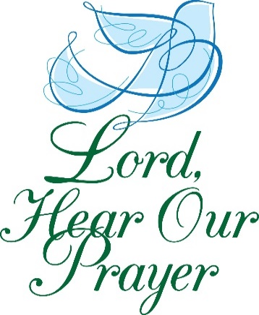  “With confidence in your love and mercy, O God, we lift our prayers for those in need. Heal them in body, mind, or circumstance, working in them, by your grace, wonders beyond all they may dream or hope. Amen.” |  | November ,  is here.  Give thanks to the Lord, for He is good; His love endures forever.  -1 Chronicles 16:34  Our Prayer List Includes  Sandra Adams, Jim Allison, Kathy Anderson, Danny Angel, Don Ashley, Linda Bain, Charlene Blair, Gerald Blankenship, Ray Blankenship, Julian & Grace Boggs, Ivy Boggess, Patti Brasure, Evelyn Brewer, Jack Bright, Billie & John Brisson, Larry Britton, Lisa Brock, Darrell Brown, Lisa Sevier Bruner, Kelsey Cader, Tamara Campbell, Merrell Carnes, Bill Christman, Elspeth Cobb, Aiden Craft, Greg Duncum, Brittany Fritte, Chad Fugitt, Mary Gabbard, David Gaddis, Donna Gilstrap, Margaret Gray, Jim Gross, Judy Hart, Dell Henderlight, Rev. Calvin Hibbard, Donna Hollis, June Hubbard, Elizabeth Hughes, Carolyn Hyden, Sam Jackson, Wayne Jenkins, Courtney & Payton Johnson, Foster Johnson, Charles Jody, Richard Jones, Billie King, Jodie Lanala, Ashley Lay, Carolyn Lawson, Jaysha Lawson, Damion Lawson, Dora Lester, Cade Lindsey, Donna Malone, Randolph Mann, Ruth Martin, Sam & Susan Martin, Brenda May, Jean McDonald, Kathryn Lay-Mclane, Jerry Messer, Johnny Miller, Lori Miracle, Rose Mitchell, Rob Mosser, Betty Mullins, Nathan Norman, Pam Omey, Crystal Partin, Joshua Penton, David Reece, Jay Riley, Linda Robinson, Earl Roden, Daniel Rose, Tony Rose, Wayne Rowlett, Margie Rynott, Robert Sandridge, Tammy & Greg Schmidt, George Scott, Linda Scott, Peter John Scray, Michael Seay, Terry Seder, Lena Seely, Glenda Sexton, Terry Sexton, Joan Schlesing, Mae Shelley, Gary Shelton, Sawyer Sherrod, Alma Smith, Keats Smith, Kenneth Sweet, Nathan Wayne Smith, Shanna Smith, Bonnie Sutton, Tommy Sutton, Arthur Strunk, Jack & Lynda Taylor, Tony Taylor, George Andrew Terrell, Ann Toadvine, Allen Trimble, Dorothy Tucker, Barbara Vanover, Susan Versaw, Family of Shane Walker, Anita Wells, Connie Wells, Joe & Brandi White, Chuck Williams, Jeremy Wilson.  Prayer requests and updates may be placed in the offering plate or shared with the Church Office.
APPLYING FOR A FOOD PANTRY CARD  If you know anyone who is in need of a Food Pantry card to receive services from the CPC Food Pantry, please refer them to Corbin’s United Effort (CUE).  CUE phone number – 606-528-7523  Hours of Operation  Tue - Thur  9:00am – 3:00pm  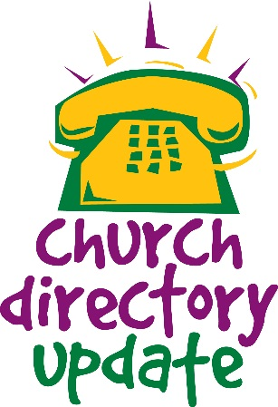  October Recap:  CPC Homecoming  October 6, 2018 | Tuesday  9am – 12pm  Volunteers are Welcome!  Our Food Pantry is a wonderful service full of hard work and dedication in an effort to provide food for the community in need. We appreciate everything each of you do, and know that the community does as well. Volunteers are always welcome to come help out with gathering and bagging items, and more.  Senior Box Program  November 28th, 9am - 12pm  Volunteers are Welcome!  Our Senior Box Program is another wonderful service that reaches out to the senior citizens in the community in need of food. Each of you who take part in it are appreciated for your efforts. Volunteers are always welcome to take part in preparation and box day.  Burnamwood 60th Anniversary Party  November 16th, 2018. 7:00-10:00pm  Location: ArtsPlace  161 North Mill Street  Lexington, KY. 40507  Tickets: $25 *Silent Auction *BBQ *Bluegrass Music  Tree of Warmth  Brisk mornings and cool evenings are reminders that it is time to start our annual collection of hats, scarves, gloves, and mittens for our Tree of Warmth.  Our food pantry clients are always excited and appreciative to choose items from our pantry tree!  A bin will be placed near the sanctuary doors for donated items.  Thank you for helping!  -Doralene Webb  Corbin Presbyterian Church Thanksgiving Dinner  We welcome all to come enjoy a time of warmth and Thanksgiving, great food and fellowship!  The dinner will take place Sunday, November 18th  at 5:00pm-7:00pm.  Turkey and dressing will be provided.  Please bring a side dish of your choice to share with the meal!  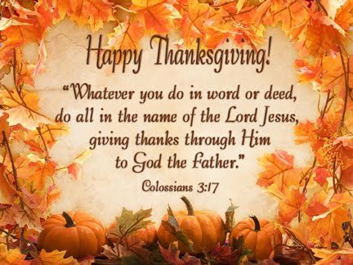  Veterans Day – Sunday, November 11th  Christ the King Sunday – November 25th  Winter Relief Ministry, 2018 Winter Season of First Baptist Church – They are serving supper each evening (except for Wednesdays and Sundays as another group covers that day). Intake and meals will be done at the former Rainbow House, blue building directly across from Tipton and Tipton on Roy Kid Avenue.  Help Needed: Any individuals - or team of people - who would like to help prepare and serve meals to our patrons, are greatly welcomed for their assistance! For any information contact Paul Sims at psims@corbinfbc.org  The church office will be closed Thanksgiving Day, November 22nd, and will also be closed the following Friday, November 23rd.  Cub Scouts are back in action now having their weekly meetings every Tuesday from 6:00-8:00pm  CHURCH EMAIL CHANGE: That’s right, we now have a new email for the church. This is one of the changes made to improve our communications and progress with the database and website! Please update the email address in your contacts and begin directing all items to it while we make this transition.  churchoffice@corbinpres.org  UNDER CONSTRUCTION: A New Church Database and Website! The database is now being put together. We’ve been hard at work to make some much-need corrections and updates to our church directories and mailing lists that will allow us to get a new website up and running! Thank you in advance for your help as we confirm the accuracy of your contact and other information. We are making good progress!  ATTENTION: Has your address, phone numbers, or email address changed? We are still gathering new and changed information from everyone with our church. We’ve made great progress already, but there are still updates needed. We don’t want anyone missing out on updates, announcements, and events so be sure to check your contact information. You’re always welcome to call or come by the office.  CHOIR REHEARSAL- Come join in voice and heart, every Wednesday 7-8pm  Care Kits – Our children are continuing to collect that will be available for our Food Pantry clients and other neighbors seeking assistance. Each Care Kit will include toothpaste, a tooth brush, shampoo, and soap. You can help by placing donations of these items in the bins in the fellowship hall. All types and sizes are helpful and welcome! (However, donations of other personal care items are not needed at this time.) If you’d like to know more about how you can help with this project, please contact Jennifer Marsh at jennifer.marsh@ucumberlands.edu  Giving for the Month of October  Regular Pledges & Offerings: $13,064.36  Food Pantry Offering & Donations: $844.22  Building Offering: $60.00  Happy Birthdays for this Month:  Dana Saunders 11/3  Phillip Martin 11/5  Maddie Sherratt 11/9  Cathy Cox 11/12  Carmel Wallace 11/16  Jane Wallace 11/16  Elspeth Cobb 11/20  Kenny Davis 11/27  A Note from your Administrative Assistant  Hello everyone,  As November encompasses a time of thankfulness as we celebrate Thanksgiving, I often take this time to really focus on what I’m thankful for. Reflection can be done differently by everyone, as often as they choose. I’ve been learning to be more reflective in my life, not just inwardly but outwardly as well. I recognize the many things that have happened in the past months, remember things from past years, I notice the construction of my life and the new additions that have been made, the hardship and the losses. It mimics the unfolding of an adventurous story. But I am not the author! And for this, I am thankful. How wonderful it is to know that our loving God above knows our story before we do, and that He walks with us every single step of the way.  Being here at CPC is my own example of being thankful for things unseen, for staying strong in faith. I am thankful to be here, for everything that I am learning between the job, the Presbyterian way, and personal growth. I have been tremendously humbled and am thankful for that, for seeing the Lord at work with the people and communities around me, and within myself.  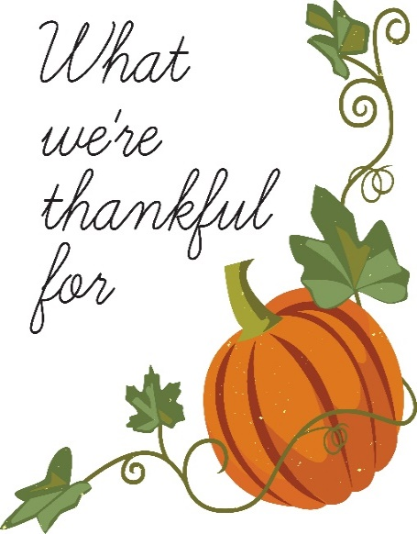  We have wonderful days, and we also have hard days that sometime we wonder why things happen the way they do. This life isn’t an easy path, but it is beautiful because we all have a glorious purpose. As I learn to be more understanding of the hard times, I realize I’m thankful for them as much as I am the good because they have helped to teach and shape me into who I am today.  As I end my monthly note to you, I want to tell you that I am so thankful for Corbin Presbyterian Church, and I am thankful for you!  Shelby Stanaford  CPC HOMECOMING 2018  This year’s Corbin Presbyterian Church Homecoming was a wonderful success with lots of fun, good food, and fellowship! We would like to share photos for everyone to enjoy.  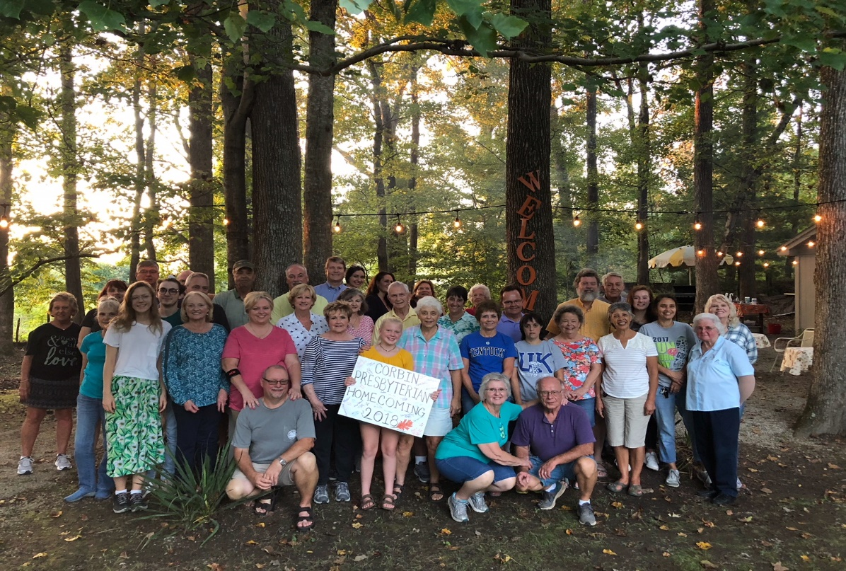  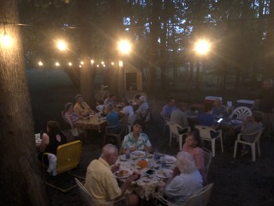  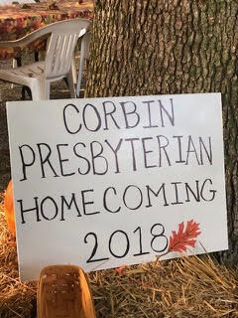  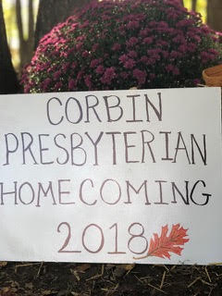
NOVEMBER CALENDER

Sunday | Monday | Tuesday | Wednesday | Thursday | Friday | Saturday
 |  |  |  | 1  Bulletin Deadline 12-1pm  TOPS Meeting 5-7pm  Tri-Presbytery Meeting 2-8pm | 2  Tri-Presbytery Meeting 8:30am-1:00pm  AL ANON Meeting 12-1pm  Presbytery Meeting | 3  Tri-Presbytery Meeting 8:30am-3:00pm  Transylvania Presb. Meeting 1-4pm
4  All Saints Sunday  Sunday School 9:45-10:45am  Worship & Communion 11:00am-12:00pm  Ordination/Install-ation of Rachel Matthews:  3-4:30pm | 5  Rev. Lisa Away-LMPC Clergy Clinic | 6  Rev. Lisa Away-LMPC Clergy Clinic  Food Pantry  9:00am-12:00pm  Cub Scouts 7-9pm | 7  Rev. Lisa Away-LMPC Clergy Clinic  Choir Rehearsal  7-8pm | 8  Rev. Lisa Away  Bulletin Deadline 12-1pm  TOPS Meeting 5-7pm | 9  Rev. Lisa back  AL ANON Meeting 12-1pm | 10  Ordination & Installation of Andrew Bowman 2-3:30pm
11  Sunday School 9:45-10:45am  Worship 11:00am-12:00pm  Book Group 6-7pm | 12 | 13  Food Pantry  9:00am-12:00pm  Cub Scouts 7-9pm  Session Meeting 6-8pm | 14  SEKMA Meeting 11:30am-12:30pm  Choir Rehearsal  7-8pm | 15  Bulletin Deadline 12-1pm  TOPS Meeting 5-7pm | 16  AL ANON Meeting 12-1pm | 17
18  Sunday School 9:45-10:45am  Worship & CentsAbility Offering 11:00am-12:00pm  Thanksgiving Dinner 5-7pm | 19 | 20  Food Pantry 9:00am-12:00pm  Cub Scouts 7-9pm | 21  Choir Rehearsal  7-8pm | 22  Church Office Closed  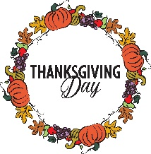 | 23  Church Office Closed  AL ANON Meeting 12-1pm (optional) | 24
25  Christ the King Sunday  Sunday School 9:45-10:45am  Worship 11:00am-12:00pm  White Flag Winter Ministry Begins 5pm | 26  Decorating for Advent  Senior Food Delivery 10-11am | 27  Food Pantry 9:00am-12:00pm  Pack Senior Boxes 6-7pm  Cub Scouts 7-9pm | 28  Senior Box Pickup Day 9:00am-1:00pm  Choir Rehearsal  7-8pm | 29  Bulletin Deadline 12-1pm  TOPS Meeting 5-7pm | 30  AL ANON Meeting 12-1pm

