 |  | Corbin Presbyterian Church Newsletter
December 2018 | Email:churchoffice@corbinpres.org Facebook:facebook.com/corbinpresby
Corbin Presbyterian Church  601 Master Street  Corbin, KY 40701  Phone:  606-528-1444  Fax:  606-526-9065  Pastor:  The Rev. Lisa R. Eye  pastor@corbinpres.org  Director of Music/Organist:  Clay Howard  pistolpete1960@gmail.com  Administrative Assistant:  Shelby Stanaford  churchoffice@corbinpres.org  Office Hours:  Monday – Friday  9:00am – 1:00pm  Pastor, Lisa Eye, is ordinarily in the church office Monday-Thursday or by appointment.  For emergencies: 859-329-9026.  Corbin Presbyterian Church is a congregation of the Presbyterian Church (U.S.A.) and one of the 82 congregations in Central and Eastern Kentucky that make up Transylvania Presbytery.  Links:  www.pcusa.org  www.transypby.org  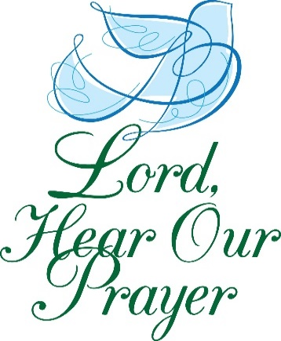  “With confidence in your love and mercy, O God, we lift our prayers for those in need. Heal them in body, mind, or circumstance, working in them, by your grace, wonders beyond all they may dream or hope. Amen.”  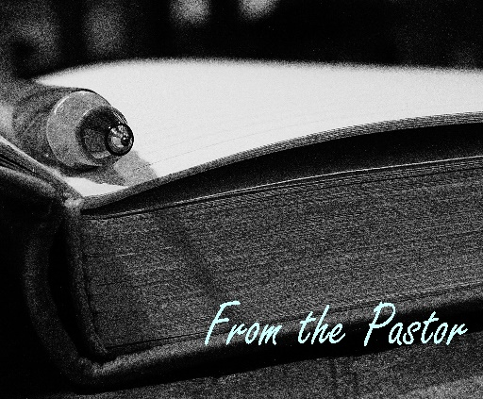 |  | 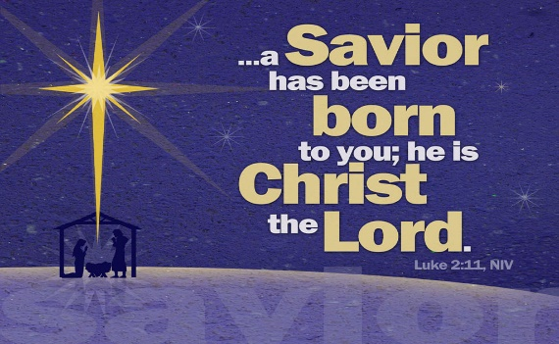  December  Our Prayer List Includes  Sandra Adams, Jim Allison, Kathy Anderson, Danny Angel, Don Ashley, Linda Bain, Charlene Blair, Gerald Blankenship, Ray Blankenship, Julian & Grace Boggs, Ivy Boggess, Patti Brasure, Evelyn Brewer, Jack Bright, Billie & John Brisson, Larry Britton, Lisa Brock, Darrell Brown, Lisa Sevier Bruner, Kelsey Cader, Tamara Campbell, Merrell Carnes, Bill Christman, Elspeth Cobb, The Family of Mike Cox, Aiden Craft, Greg Duncum, Brittany Fritte, Chad Fugitt, Mary Gabbard, David Gaddis, Francis Gilliam, Donna Gilstrap, Margaret Gray, Jim Gross, Judy Hart, Dell Henderlight, Rev. Calvin Hibbard, Donna Hollis, June Hubbard, Justin Hubbard, Elizabeth Hughes, Carolyn Hyden, Sam Jackson, Wayne Jenkins, Courtney & Payton Johnson, Foster Johnson, Charles Jody, Richard Jones, Billie King, Jodie Lanala, Ashley Lay, Carolyn Lawson, Jaysha Lawson, Damion Lawson, Dora Lester, Cade Lindsey, Donna Malone, Randolph Mann, Ruth Martin, Sam & Susan Martin, Brenda May, Jean McDonald, Kathryn Lay-Mclane, Jerry Messer, Johnny Miller, Lori Miracle, Rose Mitchell, Rob Mosser, Betty Mullins, Nathan Norman, Pam Omey, Crystal Partin, Joshua Penton, David Reece, Linda Robinson, Earl Roden, Daniel Rose, Tony Rose, Wayne Rowlett, Margie Rynott, Robert Sandridge, Tammy & Greg Schmidt, George Scott, Linda Scott, Peter John Scray, Michael Seay, Terry Seder, Lena Seely, Glenda Sexton, Terry Sexton, Joan Schlesing, Mae Shelley, Gary Shelton, Sawyer Sherrod, Alma Smith, Keats Smith, Kenneth Sweet, Nathan Wayne Smith, Shanna Smith, Bonnie Sutton, Tommy Sutton, Arthur Strunk, Jack & Lynda Taylor, Tony Taylor, George Andrew Terrell, Ann Toadvine, Allen Trimble, Dorothy Tucker, Barbara Vanover, Susan Versaw, Family of Shane Walker, Anita Wells, Connie Wells, Joe & Brandi White, Chuck Williams, Jeremy Wilson.  Prayer requests and updates may be placed in the offering plate or shared with the Church Office.  Greetings in the name of Christ! I hope everyone had a nice Thanksgiving holiday. I enjoyed a few days in Virginia to celebrate with my mother, brother and his family, and our extended Foote side of the family. It’s always good to be with family and loved ones and give thanks for the abundant blessings we enjoy and to remember the family and friends who are no longer around our table, but whose lives have blessed ours.  Now we’re turning to the Advent season that begins this Sunday, December 2nd. Thank you to everyone who has already been helping us to get ready: Ed & Sharon Valentine, Tom Blair, Chuck & Susan Williams, Corina Bryant, Betty Gaddis and Janet Martin for decorating the sanctuary; Anne Hoskins for preparing the Advent wreath and poinsettias; Ned & Doralene Webb and the rest of the Food Pantry volunteers for the Tree of Warmth; David & Mary Begley for delivering gifts to Buckhorn; and all of you who have given so generously to provide gifts for these ministries! And a special thank you to our Administrative Assistant, Shelby Stanaford, who has been so cheerful and patient as she learns about our Advent and Christmas traditions.  This Sunday is Communion Sunday and the first Sunday of Advent. We’ll hear God’s Word, light the candle of hope, and be fed at the Lord’s Table. On this and the following three Sundays of Advent we will be reminded that as the Church, the body of Christ, we tell time in a particular way. Advent challenges us to think about time in a much deeper way. Advent asks us: What are we really waiting and hoping for? How long will evil, injustice, and violence continue? What is God doing in the world? How can we in the church prepare for the coming of God’s righteousness, justice and peace?  The lectionary readings for the first Sunday in Advent center on Jesus coming again at the end of time, and the fourth and final Sunday, on Jesus coming as a baby born to Mary in Bethlehem. In between the primary figure in the Advent readings is John the Baptist and his call to repentance. The Christmas season begins with Christmas Eve when we celebrate Jesus’ birth—God’s great incarnation—coming “in the flesh” to dwell among us. We’ll celebrate with the Christmas Eve Candlelight Communion service at 6pm. Please invite friends and neighbors to any or all of these services as well as our Christmas dinner on Sunday, December 16 at 6pm.  Several members of our church family have been recovering from illness and surgeries. Please remember to pray for them. We have families that are grieving death and loss. Please remember to pray for them. Please pray for those less fortunate, for those who are hungry, for those without adequate heat or shelter, for those who are affected by addictions. Please pray for those fleeing violence and warfare.  Blessings,  Lisa  Advent Devotional Resources  There are several resources to enhance your journey through this Advent season, including some excellent online resources:  #AdventWord at www.advent.word.org is an online Advent calendar. Each day from the first Sunday of Advent through Christmas day, #AdventWord offers mediations and images to inspire and connect individuals and a worldwide community of believers to the themes of Advent. The words for #AdventWord 2018 are inspired by the Lectionary readings for Advent Year C and selected through a process of prayerful meditation on the Word. The words are intended to follow the arc of the season, preparing us to celebrate the birth of Christ. This year’s mediations are offered in eight languages and American Sign Language. You can use this resource by signing up to receive #AdventWord emails here, visiting AdventWord.org, and following the project on Facebook and Instagram.  Those of you who enjoy coloring or journaling can check out www.prayingincolor.org for Advent calendars that can be used on their own, or in combination with #AdventWord.  D365.org is an online devotional sponsored by the Presbyterian Church (U.S.A.), the Cooperative Baptist Fellowship, and the Episcopal Church that offers a short daily scripture, reflection, and prayer as well as contemplative music. The Advent devotional, Following the Star, can be found at www.d365.org .  Printed resources are also available:  The Presbyterian Outlook 2018 Advent Devotional written by Editor, Jill Duffield is a daily devotional of scriptures, mediations and prayers focusing on deepening and practicing our faith vocabulary. Each week of Advent focuses on a characteristic of God that God’s followers are also called to exhibit: patience, kindness, goodness and faithfulness.  Mary’s Song Devotional Guide by Illustrated Children’s Ministry offers scriptures, reflections and coloring pages for adults and children on each of the weekly themes of Advent: hope, peace, joy and love by reflecting on the Magnificat, Mary’s song of joy, found in Luke.  Preparing the Way: An Illustrated Advent for Families, also by Illustrated Children’s Ministry, is based on this year’s weekly lectionary scriptures, and offers reflections and activities for children and adults.  Look for all of these and other resources in the fellowship hall.
APPLYING FOR A FOOD PANTRY CARD  If you know anyone who is in need of a Food Pantry card to receive services from the CPC Food Pantry, please refer them to Corbin’s United Effort (CUE).  CUE phone number – 606-528-7523  Hours of Operation  Tue - Thur  9:00am – 3:00pm  Tree  of Warmth  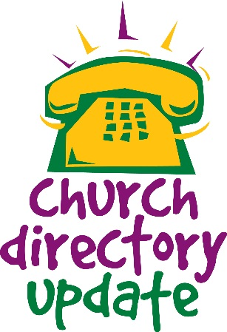 | Tuesday  9am – 12pm  Volunteers are Welcome!  Our Food Pantry is a wonderful service full of hard work and dedication in an effort to provide food for the community in need. We appreciate everything each of you do, and know that the community does as well. Volunteers are always welcome to come help out with gathering and bagging items, and more.  Senior Box Program  December 19th, 9am - 1pm  Volunteers are Welcome!  Our Senior Box Program is another wonderful service that reaches out to the senior citizens in the community in need of food. Each of you who take part in it are appreciated for your efforts. Volunteers are always welcome to take part in preparation and box day.  The Tree of Warmth is still accepting donated items of hats, scarves, gloves, and mittens.  Our food pantry clients are always excited and appreciative to choose items from our pantry tree!  The bin is placed near the sanctuary doors for the donated items. You are also welcome to drop them off by the church office!  Thank you for helping!  -Doralene Webb  Corbin Presbyterian Church  Christmas Dinner  ~  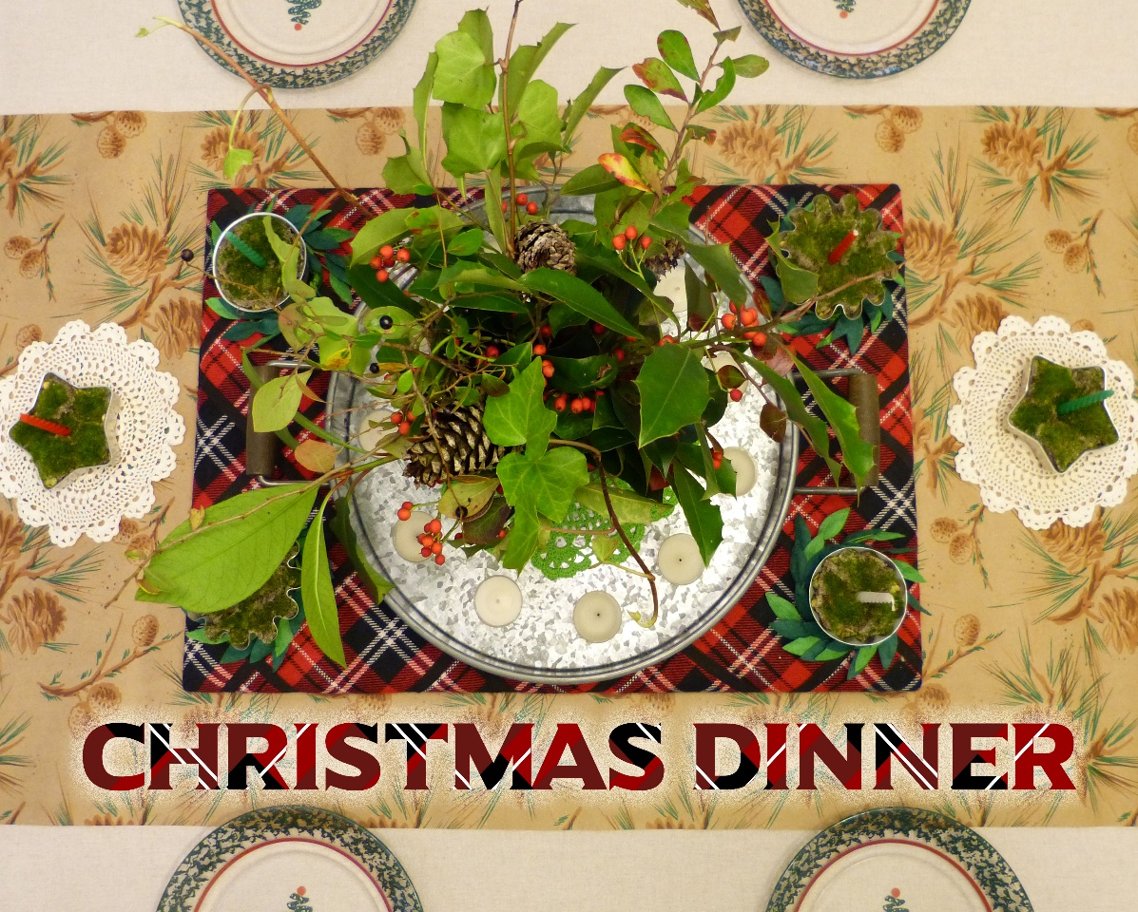  Sunday, December 16th from 5:00-6:00pm  We look forward to seeing everyone!  ADVENT begins Sunday, December 2nd  Annual Pipe Organ Concert – This year’s concert will take place at First Christian Church on Monday, December 3rd at 7:00pm. We are excited to have our own Clay Howard to be performing as one of the featured organists. Everyone is welcome to attend!  Our next Kids Event will be – Sunday, December 9th, 4:00-5:30pm  Care Kits – Our children are continuing to collect that will be available for our Food Pantry clients and other neighbors seeking assistance. Each Care Kit will include toothpaste, a tooth brush, shampoo, and soap. You can help by placing donations of these items in the bins in the fellowship hall. All types and sizes are helpful and welcome! (However, donations of other personal care items are not needed at this time.) If you’d like to know more about how you can help with this project, please contact Jennifer Marsh at jennifer.marsh@ucumberlands.edu  Buckhorn Christmas Gifts – Supporting the ministry of Buckhorn Children’s Center in Buckhorn, KY by providing Christmas gifts for residents has become an important annual tradition! The Buckhorn Campus in Central Appalachia is where Harvey S. Muchdoch founded the ministry in 1902 as an orphanage and school, Witherspoon College, for children in that isolated mountain region. Today, Buckhorn’s ministry reaches across the state to provide a sanctuary of health, healing, and hope to well over one thousand at-risk children and families touched by abuse and neglect at its two residential campuses and community-based centers. This year we have received “wish lists” for the 13-17 year-old female residents of Rogers Cottage on the Buckhorn Campus, along with a list of items for the cottage that are shared by all the residents. If you would like to help with this ministry, please see the bulletin board in the fellowship hall.  The deadline for gifts to be returned to the church is Thursday, December 13th. Gifts should not be wrapped and should be marked with name of the intended recipient. However, donations of gift bag(s) with tissue, wrapping paper, bows, ribbons, tape, etc., are welcomed.  Mary and Dave Begley will be delivering the gifts to Buckhorn on Friday, December 14.^{th} Please let them know if you would like to go with them. To learn more about the ministry of Buckhorn, go to www.buckhorn.org.  Christmas Dinner – We will be having our Christmas Dinner on Sunday, December 16th from 5-6pm.  Christmas Eve Candlelight Communion Service – Monday, December 24th at 6pm  Rev. Susan Williams – providing sermon on December 30th  The Church Office will be closed on Christmas Day as well as the following day; Wednesday, December 26th.  Winter Relief Ministry, 2018 Winter Season of First Baptist Church – They are serving supper each evening (except for Wednesdays and Sundays as another group covers that day). Intake and meals will be done at the former Rainbow House, blue building directly across from Tipton and Tipton on Roy Kid Avenue.  Help Needed: Any individuals - or team of people - who would like to help prepare and serve meals to our patrons, are greatly welcomed for their assistance! For any information contact Paul Sims at psims@corbinfbc.org  Cub Scouts are back in action now having their weekly meetings every Tuesday from 6:00-8:00pm  Winter Solstice – The first day of winter begins Friday, December 21st  CHURCH EMAIL CHANGE: That’s right, we now have a new email for the church. This is one of the changes made to improve our communications and progress with the database and website! Please update the email address in your contacts and begin directing all items to it while we make this transition.  churchoffice@corbinpres.org  UNDER CONSTRUCTION: A New Church Database and Website! The database is now being put together. We’ve been hard at work to make some much-need corrections and updates to our church directories and mailing lists that will allow us to get a new website up and running! Thank you in advance for your help as we confirm the accuracy of your contact and other information. We are making good progress!  ATTENTION: Has your address, phone numbers, or email address changed? We are still gathering new and changed information from everyone with our church. We’ve made great progress already, but there are still updates needed. We don’t want anyone missing out on updates, announcements, and events so be sure to check your contact information. You’re always welcome to call or come by the office.  CHOIR REHEARSAL- Come join in voice and heart, every Wednesday 7-8pm  We will not be having choir rehearsal on Wednesday December 26th  Giving for the Month of November  Regular Pledges & Offerings: $ 12,629.52  Food Pantry Offering & Donations: $554.13  Building Fund Offering: $60.00  Happy Birthdays for this Month:  Richard Sadler 12/3  Marianne Trimble 12/5  Madison Bricker 12/10  Mary Begley 12/17  Lisa Black 12/21  Katherine Hoskins 12/27  Susan Martin 12/27  Jim Garrison 12/30  Chrismon Tree  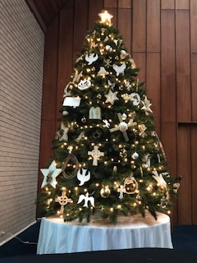  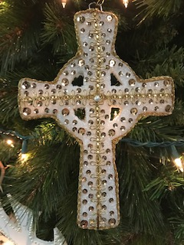  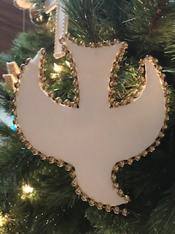  A Note from your Administrative Assistant  As this will be my first Christmas with Corbin Presbyterian Church, I am already in awe at all of the events that are taking place and those to come, between all the church is involved with in helping others and the reasons we celebrate Christmas.  This is one of my most favorite times of the year; truly a humbling time when recognizing that everything changed with the birth of Jesus Christ. A truly blessed reason, to celebrate the miracle of the season! As I also learn more about Advent, and am getting to see all of the intricate parts that play such important roles, my heart is moved.  As 2018 also comes to an end this month, I count all of my blessings being with this church for six months along with all of the things that have come with it. I look forward to beginning a new year with everyone in January.  I want to wish everyone a wonderful and blessed Merry Christmas. I hope everyone stays warm, enjoys family and friends, receives peace and joy, stays safe in travels, and enjoys the reason for the season!  -Shelby Stanaford

DECEMBER CALENDER

Sunday | Monday | Tuesday | Wednesday | Thursday | Friday | Saturday
 |  |  |  |  |  | 1
2  1st Advent  Sunday School 9:45-10:45am  Worship 11am | 3 | 4  Food Pantry 9am-12pm  Cub Scouts 6-8pm | 5  Choir Rehearsal 7-8pm | 6  Bulletin Deadline 12pm  TOPS Meeting 5-7pm | 7  AL ANON 12-1pm | 8
9  2nd Advent  Sunday School 9:45-10:45am  Worship 11am  Kid’s Event 4-5:30pm | 10 | 11  Food Pantry 9am-12pm  Session Meeting 6-8pm  Cub Scouts 6-7pm | 12  SEKMA 11:30am-12:30pm  Choir Rehearsal 7-8pm | 13  Buckhorn Gifts Deadline  Bulletin Deadline 12pm  TOPS Meeting 5-7pm | 14  Buckhorn Gifts Delivery  AL ANON 12-1pm | 15
16  3rd Advent  Sunday School 9:45-10:45am  Worship & CentsAbility 11am  Christmas Dinner 5-6pm | 17  Senior Box Delivery 10am | 18  Food Pantry 9am-12pm  Pack Senior Boxes 6-7pm  Cub Scouts 6-7pm | 19  Senior Box PickUps 9am-1pm  Choir Rehearsal 7-8pm | 20  Bulletin Deadline 12pm  TOPS Meeting 5-7pm | 21  AL ANON 12-1pm | 22
23  4th Advent  Sunday School 9:45-10:45am  Worship 11am | 24  Christmas Eve  Christmas Eve Service – 6pm | 25  Rev. Lisa away  Christmas Day – Church Office Closed | 26  Rev. Lisa away  Church Office Closed | 27  Rev. Lisa away  Bulletin Deadline 12pm  TOPS Meeting 5-7pm | 28  Rev. Lisa away  AL ANON 12-1pm | 29  Rev. Lisa away
30  1st Sunday after Christmas  Rev. Lisa away  Sunday School 9:45-10:45am  Worship 11am | 31  New Year’s Eve  Rev. Lisa away | Jan. 1  New Year’s Day Church Office Closed  Re. Lisa away | Jan. 2  Rev. Lisa away | Jan. 3  Rev. Lisa back

