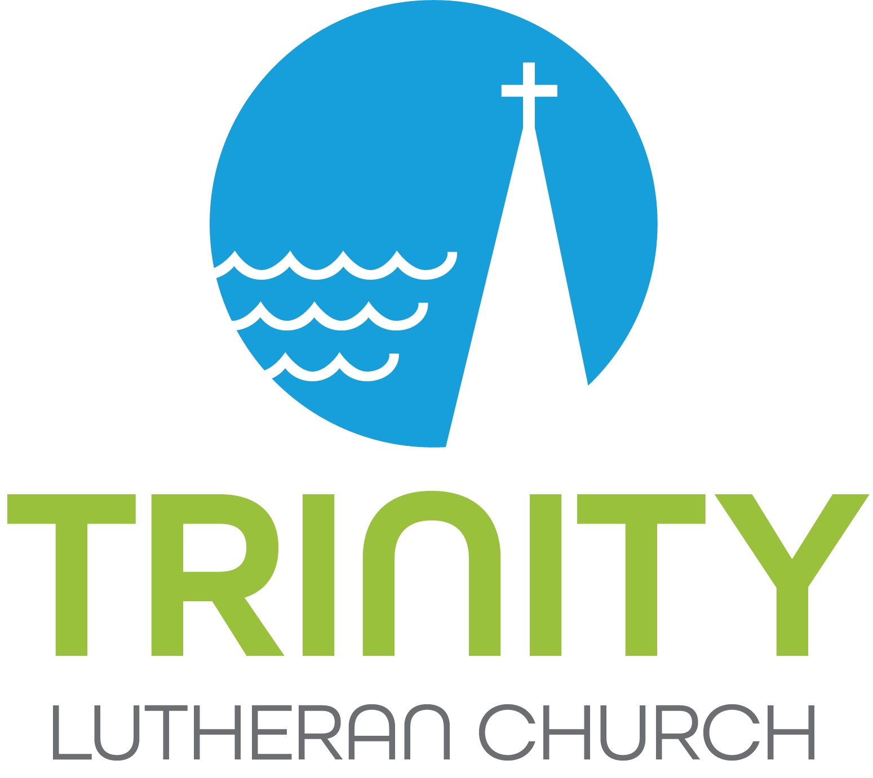 | Position Description – 2/19/20

Position Title:  Children’s Ministry Faith Formation Coordinator  (Birth - Grade 5) | FLSA Status: X Exempt Non-Exempt
Date of Position Description: February 2020
(to be evaluated/reviewed/adjusted annually)
Position Reports to: Pastor of Lifelong Faith Formation
Position Summary: Plan, create, and implement faith formation environments, curriculums, and activities that support and encourage children and equip families for Trinity’s Mission:
Because God first loved us, we live as Jesus in the world, loving God and loving neighbor.

Essential Functions of the Position:

Young Family Faith Formation (birth to 4 yrs)
-Help lead Baptism Orientation for families seeking baptism at Trinity (often young families)
-Build relationships with young families (Grace Space, Milestones, events)
-Partner with LADC in coordination of several joint events per year (i.e. Trunk ‘R Treat, Easter Egg Hunt….)

Sunday Faith Formation (4 yrs to Grade 5):
-Nurture the connection between worship and faith formation for the whole community
-Develop curriculum that nurtures the single story on Sunday mornings (Revised Common Lectionary)
-Recruit, train, equip, and support ministry and small group leaders.
-Recruit, train, equip and support other volunteers including helpers of crafts/activities, music, welcome/check-in, subs, etc.
-Secure handouts/supplies needed throughout the year.
-Lead/Teach throughout the year.
-Manage weekly offerings.
-Coordinate children singing/participating in some worship services.
-Communicate with parents throughout the year – Incorporate them whenever possible (building on this each year).
-At end of year, evaluate with and thank the above volunteer leaders.

Milestones (birth-Grade 5)
-Develop age-appropriate Milestones for families to celebrate growth, learning, and God’s presence for every age and stage
-Help families connect their big and small moments to faith
-Recruit, train, equip, and support teams to share leadership and stories of Milestones
-Recruit, train, equip and support other volunteers including subs, special speakers, etc.
-Secure handouts/supplies needed throughout the year.
-Communicate with parents throughout the year – Incorporate them whenever possible (building on this each year)
-At end of year, evaluate with and thank the above volunteer leaders.

Cross-generational Faith Formation:
-Work with families to cultivate relationships throughout the ages, support 5 significant faith mentors
-Help develop All-In events for families of all ages in coordinator with CYF and Ministry Teams
-Name and claim where and when meaningful intergenerational experiences have happened (tell the stories)

Sacraments (baptism & communion):
-Together with the Pastor of Lifelong Faith Formation, develop and implement Trinity’s plan to cover the sacraments.
-Communion: two half-day retreat offerings for students and their parents
-Baptism: one entry in conjunction with new member process

Vacation Bible School and Summer Bible Camp:
-Collaborate and partner with VBS team.
-Collaborate and partner with WAPO Bible Camp to hold dates/spots for Trinity kids.
-Communicate (and encourage attendance) to students and parents in as many ways as possible throughout the year.
-Help create and execute fundraising opportunities for families.
-Trinity Middle & High School Coordinator holds camp-related details during summer.

Additional Responsibilities:
-Uphold the Mission and Core Values of Trinity
-Manage Children’s Ministry Budget (birth – Grade 5)
-Attend weekly CYF staff meetings & work in collaboration and partnership
-Support Confirmation and Youth Ministry as needed
-Attend All-Staff meetings and work in collaboration and partnership whenever possible
-Scheduling/calendaring
-Work in collaboration with Trinity Communications Manager – share pictures whenever possible!
-Be present at Sunday Worship, Annual Meeting, Etc. to connect with students, families and congregation members.
Qualifications:
- Two or more years of experience in ministry programming
- Understanding of Childhood Development
- Ability to articulate personal faith story and God’s story
- Curriculum and development discernment experience
- Background in recruiting, training and ongoing support of adult and youth volunteers
- Comfortable with technology and social media
- Ability to work independently, as well as in a team setting
- Excellent oral and written communication skills
- Ability to effectively prioritize and meet deadlines
- Comfortable speaking in front of large groups
Note: Nothing in this job description restricts management’s right to assign or reassign duties and responsibilities to this job at any time.

