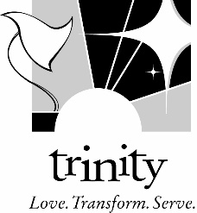

SCHOLARSHIP REQUEST FORM

Effective September 2016, the following policy will be in effect for all Scholarship Requests involving Children, Youth and Family Ministries at Trinity Lutheran Church:

- In order to receive a scholarship, the family or youth must be a registered member in our ministries or active in the Trinity community.
- Families can only receive a scholarship for up to half of the program/event fee for which a scholarship is being requested (ex. Program cost is $100, a scholarship would be available up to $50). In this way, we will be able to assist more families and families will feel more invested in the program or event their child is attending.
- Scholarship requests will be reviewed by the Children, Youth, and Family Staff at Trinity and approved at their discretion.
- If additional Scholarship Forms are needed, they can be found on the Trinity website, under ‘Register’ on the home page.

Event Information
Event student would like to attend: | Event Date(s): | Total Cost of the Program:
Amount of scholarship requested:

(You are responsible for at least half of the program/event fee)

Student Information
Name of Participant:
Grade: | Member of Trinity? Yes No

Parent Information
Parent/Guardian Name(s): | Cell Phone: | Email:
Address:

Upon receipt of this form, Trinity’s CYF team will review the request and get back to you as soon as possible. Upon approval, Trinity will pay the requested amount to the program of choice. Please return this form to Trinity prior to the program/event registration deadline.

Parent/Guardian Signature: | Date:

FOR INTERNAL USE ONLY:  Approved by: | Date:
Program Acct. Number

